**Analyzing Kellogg’s Cornflake’s Sales and Customer Preferences**

**I. Introduction:**

Kellogg's Cornflakes is a popular breakfast cereal manufactured by Kellogg's, a multinational food company founded in 1906. It is made from toasted flakes of corn and is known for its crispy texture and mild flavor. Kellogg's Cornflakes is often enjoyed with milk and can be topped with fruits or honey for added sweetness. It is a source of vitamins and minerals, making it a nutritious choice for breakfast or a snack. Kellogg's Cornflakes is marketed as a healthy and convenient breakfast option, suitable for all ages.

**II. Objective:**

To analyze the responses from the questionnaire on Kellogg's Cornflakes to gain insights into consumer behavior, preferences, and perceptions towards the product. The analysis aims to identify patterns, trends, and relationships within the data to inform marketing strategies and product development decisions.

Overall, the analysis of the questionnaire responses will provide valuable insights into consumer behavior and preferences, which can be used to enhance the marketing strategy and product offering of Kellogg's Cornflakes.

Questionnaire:

1. Age: The age of the respondent can provide insights into the target demographic for cornflakes consumption. It helps in understanding preferences and consumption patterns across different age groups.
2. Gender: Gender can help in analyzing any gender-specific preferences or trends in cornflakes consumption. It can also provide insights into marketing strategies targeting specific genders.
3. What is your weight (in kg) ? :Weight can be correlated with consumption habits and health consciousness. It can help in understanding if there is any relation between weight and cornflakes consumption.
4. What is your annual household income ? :This question helps in understanding the purchasing power and spending behavior of different income groups. It can also indicate the affordability and value perception of cornflakes.
5. Are you diabetic ? :This question is important to understand the health conditions of the respondents. It can help in analyzing the preference for low-sugar or diabetic-friendly products like cornflakes.
6. Which flavor of Kellogg's Cornflakes do you consume ? :Understanding the flavors preferred by consumers helps in product development and marketing strategies. It can also indicate the popularity of different flavors among consumers.
7. How many bowls of Kellogg's Cornflakes do you have in a week ? : This question provides an estimate of the frequency of cornflakes consumption. It helps in understanding consumption habits and preferences.
8. What time of the day do you usually consume Kellogg's Cornflakes ? :Knowing when consumers prefer to eat cornflakes can help in targeted marketing and product positioning. It can also indicate usage occasions and meal preferences.
9. How would you rate the flavor of Kellogg's Cornflakes? : This rating helps in gauging the satisfaction level of consumers with the flavors of cornflakes. It can indicate which flavors are more popular or need improvement.
10. How much do you spend in a month on Kellogg's Cornflakes ? : This question provides insights into the spending behavior of consumers on cornflakes. It helps in understanding the price sensitivity and value perception of the product.
11. How likely are you to continue buying Kellogg's Cornflakes in the future? : Understanding the likelihood of repeat purchases helps in evaluating customer loyalty and satisfaction. It can also indicate areas for improvement in the product or marketing strategies.
12. How likely are you to recommend Kellogg's Cornflakes to others ? : This question measures the advocacy of consumers for cornflakes. It helps in understanding brand loyalty and word-of-mouth marketing potential.
13. Which region in Mumbai do you reside in ? : Knowing the region helps in analyzing regional preferences and trends. It can also help in localizing marketing strategies and product offerings.
14. Rate the packaging of Kellogg's Cornflakes : This rating helps in evaluating the effectiveness of the packaging in attracting consumers. It can indicate the perception of the brand and product presentation.
15. Do you think Kellogg's Cornflakes is a healthy breakfast ? : This question helps in understanding the perception of consumers regarding the healthiness of cornflakes. It can indicate the importance of health factors in purchasing decisions.

**III. Methodology:**

**a) Data Collection:**

The data for this analysis was collected through a Google Form survey distributed to a sample of consumers. The survey, conducted using voluntary response sampling, gathered information on various aspects related to Kellogg's Cornflakes. It was distributed through social media, email campaigns, and online forums to reach a diverse group of respondents. The survey was designed to be simple, mobile-friendly, and anonymous to ensure privacy and encourage honest feedback. The data collection process was conducted over a specified period to ensure a sufficient sample size for analysis, with respondents voluntarily participating in the survey. This method of data collection is also known as external data collection, as the data was gathered from sources outside the organization conducting the study.

**b) Data Analysis:**

For the analysis of the Kellogg's Cornflakes survey data, we performed the following types of analysis:

1. Descriptive Analysis: Calculated the mean, median, and standard deviation for age, weight, annual household income, flavor rating, packaging rating, health rating, bowls per week, and monthly spend on cornflakes.
2. Graphical Representation: Created histograms to visualize the distributions of age, weight, monthly spend on cornflakes, flavor rating, packaging rating, health rating, and bowls per week. Also created pie charts to show the proportions of gender and residence categories.
3. Correlation Analysis: Calculated correlations between variables such as age, weight, monthly spend on cornflakes, flavor rating, packaging rating, health rating, and bowls per week to identify any relationships between these variables.
4. Regression Analysis: Used regression analysis to predict monthly spend on cornflakes based on other variables in the dataset.
5. Hypothesis Testing: Conducted hypothesis tests to compare various factors such as gender, diabetes status, and residence with monthly spend on cornflakes or likelihood to continue buying.
6. ANOVA: Analysis of Variance (ANOVA) is utilized to compare the means of three or more groups to ascertain if there are statistically significant differences among them.
7. MANOVA: is used when there are multiple dependent variables to analyze simultaneously, allowing for a more efficient and comprehensive assessment of the effects of independent variables across these variables.
8. Maximum Likelihood Estimator: Maximum Likelihood Estimator (MLE) is a method used to estimate the parameters of a statistical model. It finds the parameter values that maximize the likelihood function, which measures the likelihood of the observed data given the model parameters. We are using MLE here to estimate the parameters of the MANOVA model, such as the means and covariances of the dependent variables for each group, based on the observed data, in order to test the hypothesis of differences between groups.

These analyses provided insights into consumer behavior and preferences regarding Kellogg's Cornflakes, helping to inform marketing strategies and product development decisions.

**c) Visualization:**

Visualization is a powerful tool in data analysis and presentation, helping to communicate complex information in a clear and understandable way. Here are some commonly used visualization tools:

1. Bar Chart: A bar chart is used to compare the frequency, count, or percentage of different categories. Each bar represents a category, and the length of the bar represents the value.
2. Histogram: A histogram is used to visualize the distribution of a continuous variable. It consists of bars that show the frequency or count of data within each interval or bin.
3. Pie Chart: A pie chart is used to show the proportion of different categories in a dataset. Each slice of the pie represents a category, and the size of the slice represents the proportion of data in that category.
4. Scatter Plot: A scatter plot is used to visualize the relationship between two continuous variables. Each point on the plot represents a data point, with the x-axis showing one variable and the y-axis showing the other variable.
5. Box Plot: A box plot is used to show the distribution of a continuous variable and identify outliers. It consists of a box that represents the interquartile range (IQR) and whiskers that extend to the minimum and maximum values within 1.5 times the IQR.
6. Heat Map: A heat map is used to visualize data in a matrix format, where each cell is color-coded based on the value. Heat maps are often used to show relationships or patterns in large datasets.

These visualization tools can help you explore and understand your data, identify patterns and trends, and communicate your findings effectively to others.

c)

**IV. Result and Analysis:**

1. **Descriptive Analysis:**

Loading the data

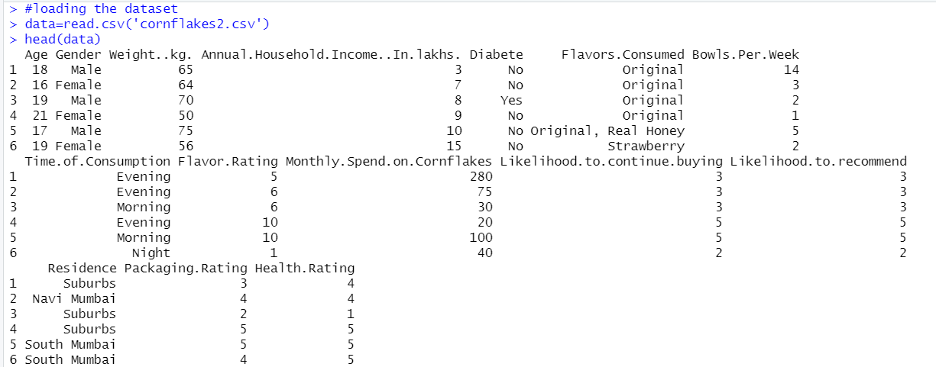

1. Descriptive Analysis for Age column:

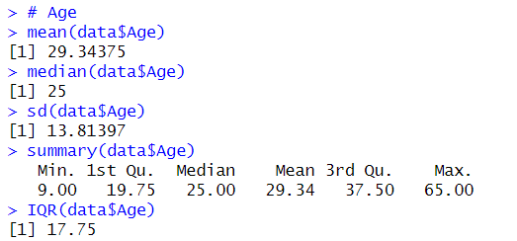

1. Descriptive Analysis for Gender Column:

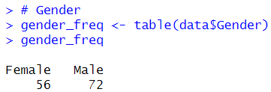

1. Descriptive Analysis for Weight Column:

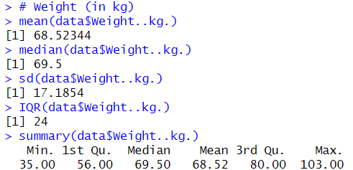

1. Descriptive Analysis for Annual Household Income

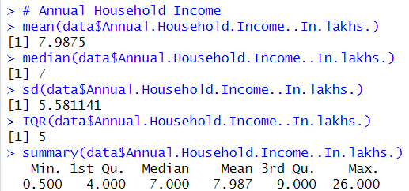

1. Descriptive Analysis for Diabetes Column:

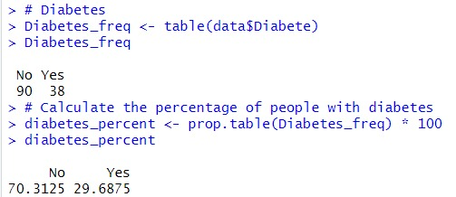

Converting Categorical Data to Numerical Data:

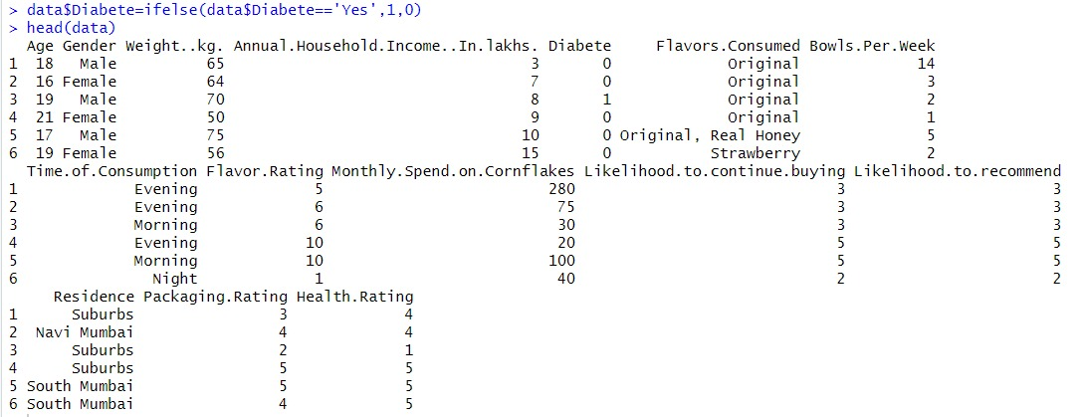

1. Descriptive Analysis for Flavors Consumed Column:

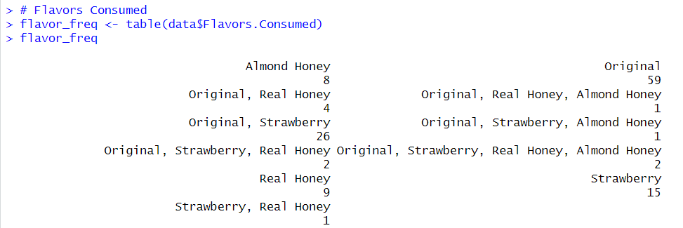

1. Descriptive Analysis of Bowls per week column:

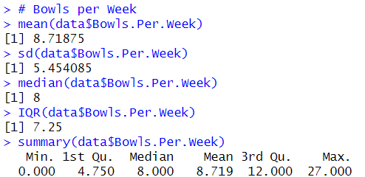

1. Descriptive Analysis for Time of Consumption Column:

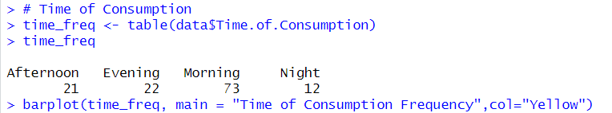

1. Descriptive Analysis for Flavor Rating Column:

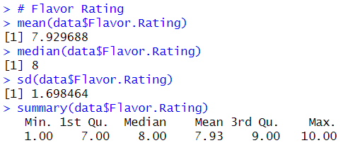

1. Descriptive Analysis for Monthly Spend Column:

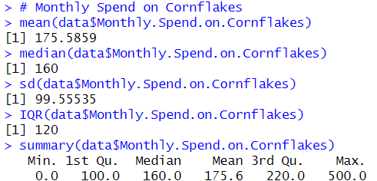

1. Descriptive Analysis for Likelihood to continue buying column:

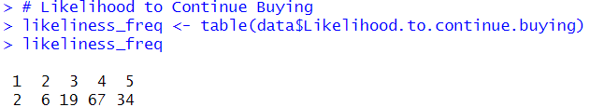

1. Descriptive Analysis for Likelihood to Recommend column:

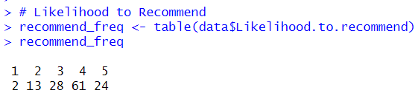

1. Descriptive Analysis for Residence Column:

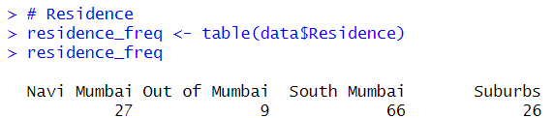

1. Descriptive Analysis for Packaging Rating Column:

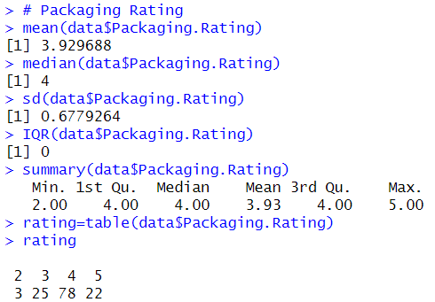

1. Descriptive Analysis for Health Rating Column:

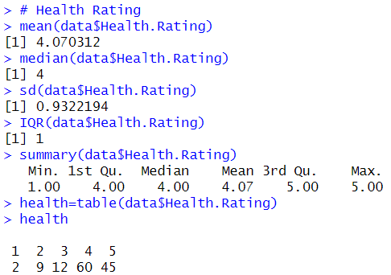

1. **Graphical Representation of Data Columns:**
2. Histogram for Age Column:



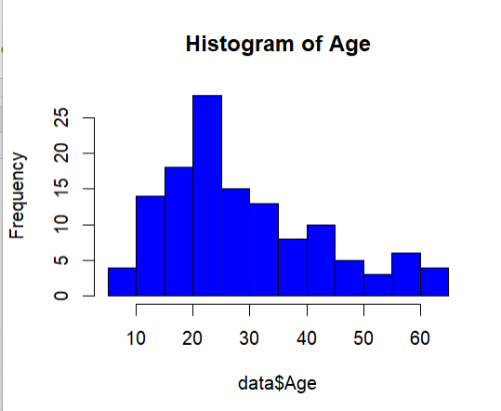

1. Pie Chart for Gender Column:

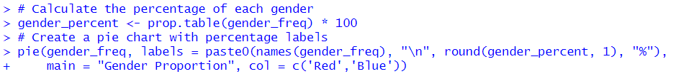

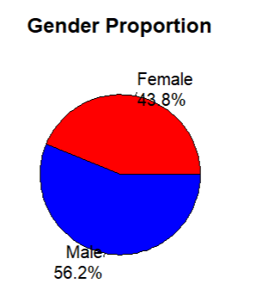

1. Histogram for Weight Column:



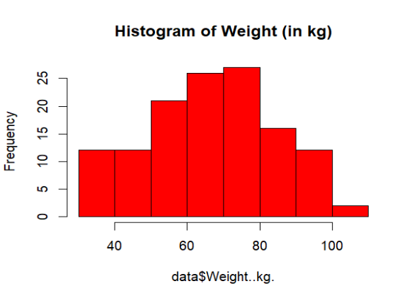

1. Boxplot and Histogram for Annual Household Income Column:



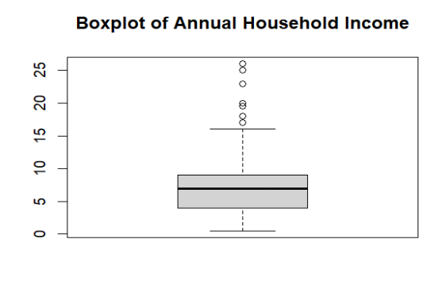



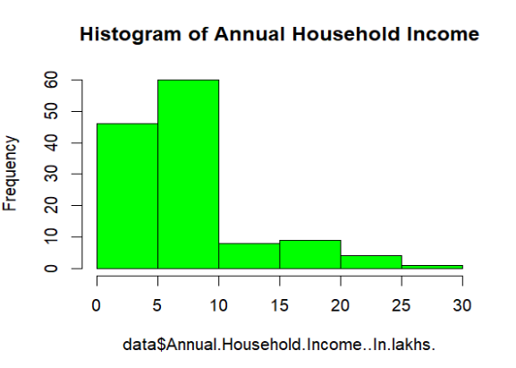

1. Pie Chart for Diabetes Column:



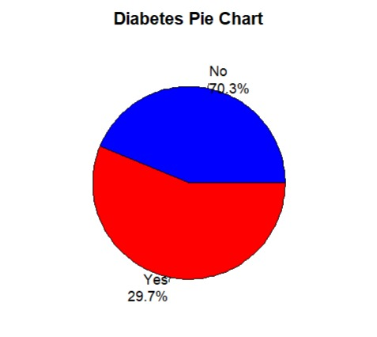

1. Bar Plot and Pie Chart for Flavors Consumed Column:





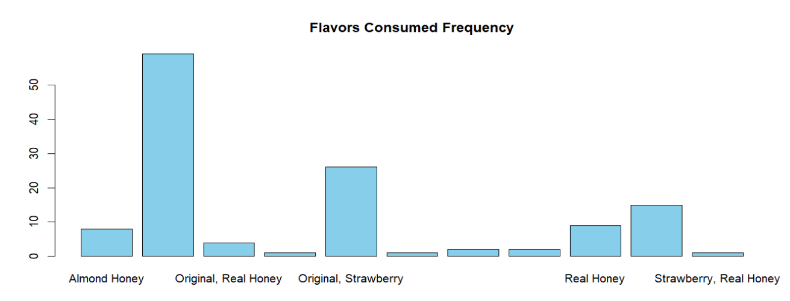

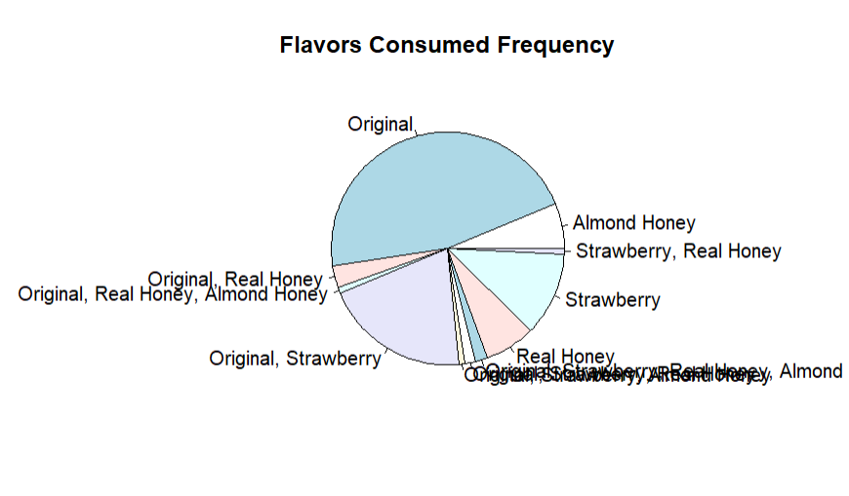

1. Histogram for Bowls per Week Column:



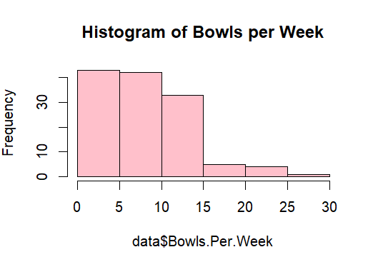

1. Bar Plot and Pie Chart for Time of Consumption Column:



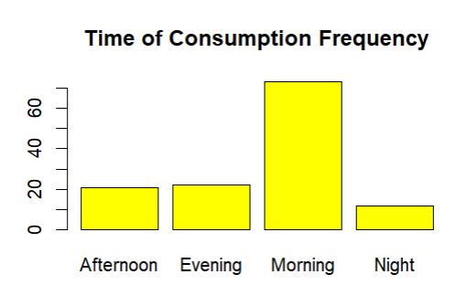

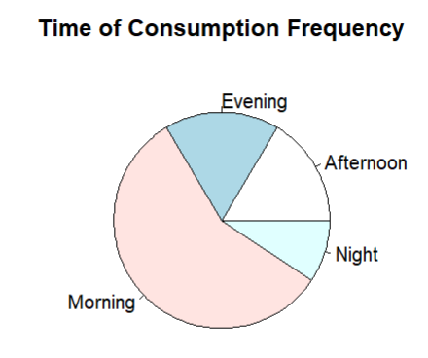

1. Histogram for Flavor Rating Column:



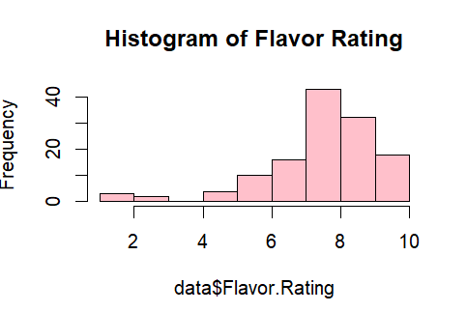

1. Histogram for Monthly Spend Column:



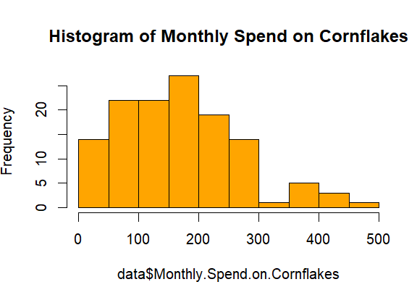

1. Bar Plot and Pie Chart for Likelihood to Continue Buying Column:





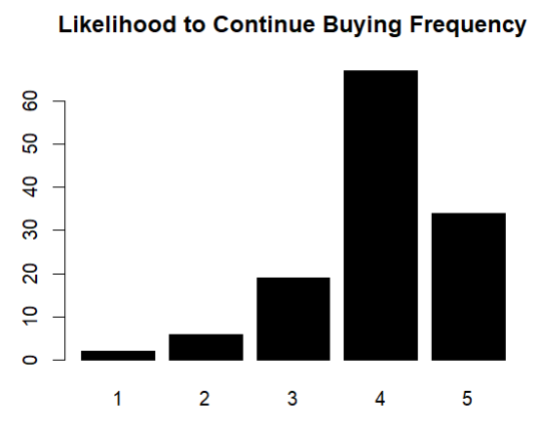

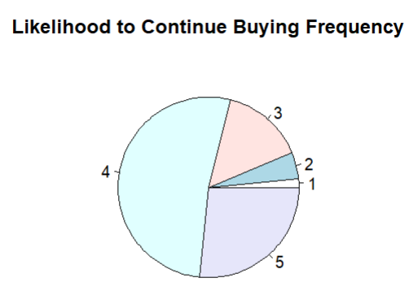

1. Bar Plot and Pie Chart for Likelihood to Recommend Column:



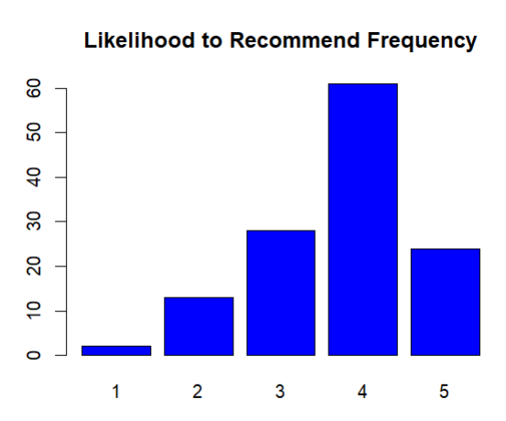

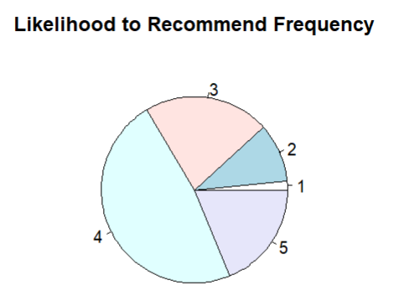

1. Bar Plot and Pie Chart for Residence Frequency:



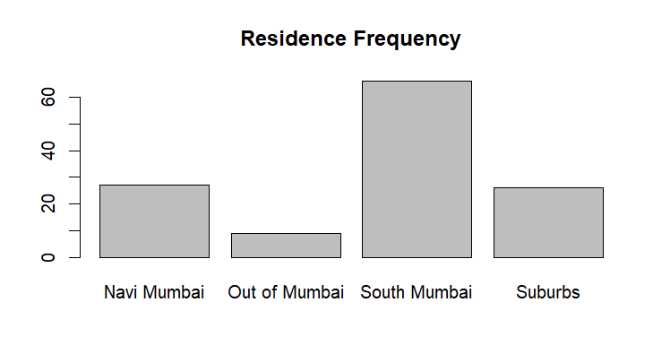

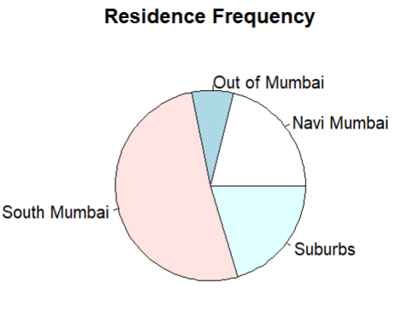

1. Bar Plot and Pie Chart for Packaging Rating Column:



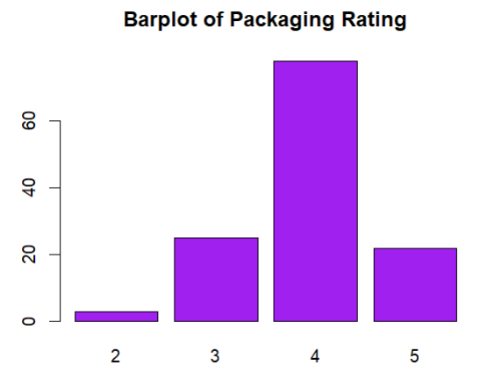

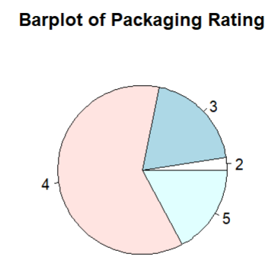

1. Bar Plot and Pie Chart for Health Rating:



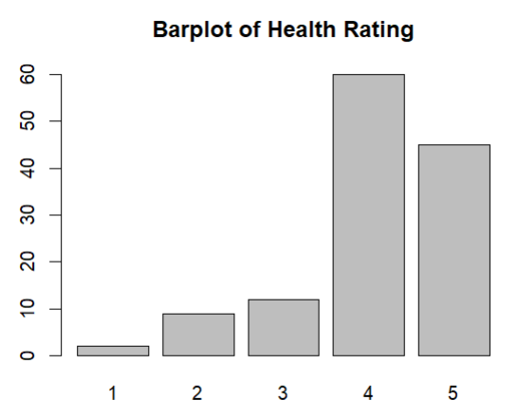

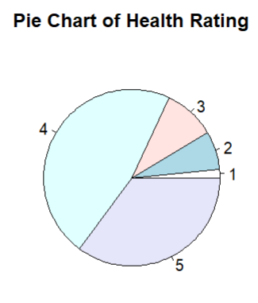

1. **Correlation Analysis:**

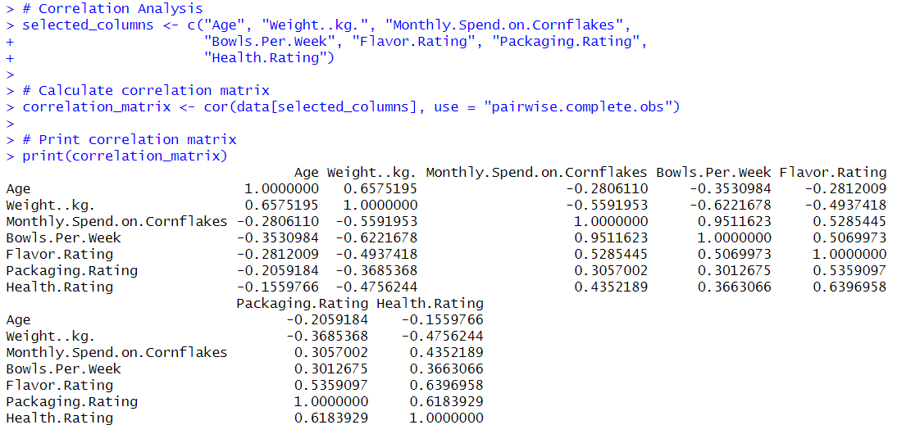

To calculate the correlation matrix, we used the cor function in R, which computes the correlation coefficient between pairs of variables in a dataset. The method used to calculate the correlation coefficient is Pearson's correlation, which measures the linear relationship between two variables. Pearson's correlation coefficient ranges from -1 to 1, where:

* A correlation of 1 indicates a perfect positive linear relationship, meaning that as one variable increases, the other variable also increases proportionally.
* A correlation of -1 indicates a perfect negative linear relationship, meaning that as one variable increases, the other variable decreases proportionally.
* A correlation of 0 indicates no linear relationship between the variables.

In our analysis, we used the default method of the cor function, which calculates Pearson's correlation coefficient. We also used the argument use = "pairwise.complete.obs" to handle missing values by computing correlations using pairwise complete observations, ensuring that only complete cases are used in the calculation of each correlation coefficient.

Conclusion:

1. Age and Weight (in kg): There is a strong positive correlation of approximately 0.66, indicating that as age increases, weight tends to increase as well.
2. Monthly Spend on Cornflakes and Weight (in kg): There is a moderate negative correlation of approximately -0.56, suggesting that as weight increases, the monthly spend on cornflakes tends to decrease.
3. Monthly Spend on Cornflakes and Bowls Per Week: There is a strong positive correlation of approximately 0.95, indicating that as the number of bowls consumed per week increases, the monthly spend on cornflakes also increases.
4. Flavor Rating and Packaging Rating: There is a moderate positive correlation of approximately 0.54, suggesting that there is some relationship between how consumers rate the flavor and packaging of the product.
5. Flavor Rating and Health Rating: There is a strong positive correlation of approximately 0.64, indicating that consumers who rate the flavor of the product higher also tend to rate its healthiness higher.

Overall, these correlations provide insights into potential relationships between different variables in the dataset, which can be valuable for understanding consumer behavior and making informed marketing decisions.

1. **Regression Analysis:**

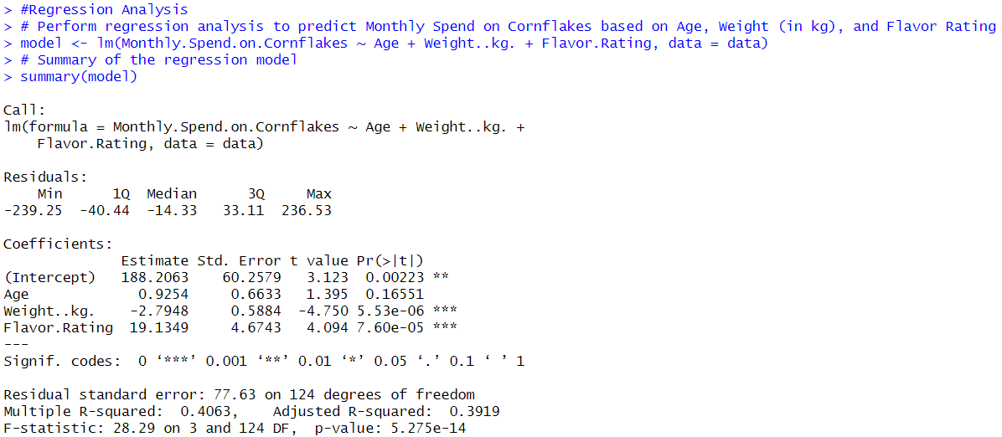

In this code:

* Monthly Spend on Cornflakes is the dependent variable, and Age, Weight (in kg), and Flavor Rating are the independent variables.
* The lm function is used to fit a linear regression model to the data.
* The data argument specifies the dataset containing the variables.
* The summary function provides a summary of the regression model, including coefficients, standard errors, t-values, p-values, and R-squared.

Conclusion:

Based on the linear regression analysis results:

1. Intercept: The intercept term is statistically significant (p = 0.00223), indicating that even with age, weight, and flavor rating held constant, there is still a base level of monthly spend on cornflakes.
2. Age Coefficient: The coefficient for age is not statistically significant (p = 0.16551), suggesting that age may not have a significant impact on monthly spend on cornflakes when weight and flavor rating are taken into account.
3. Weight Coefficient: The coefficient for weight (in kg) is statistically significant (p < 0.001), indicating that for each additional kilogram of weight, there is a decrease of approximately Rs. 2.79 in monthly spend on cornflakes, when age and flavor rating are held constant.
4. Flavor Rating Coefficient: The coefficient for flavor rating is statistically significant (p < 0.001), suggesting that for each additional point increase in flavor rating, there is an increase of approximately Rs. 19.13 in monthly spend on cornflakes, when age and weight are held constant.
5. Overall Model Fit: The overall model is statistically significant (p < 0.001), indicating that the predictors (age, weight, and flavor rating) together explain a significant amount of the variability in monthly spend on cornflakes. The multiple R-squared value of 0.4063 suggests that approximately 40.63% of the variability in monthly spend on cornflakes can be explained by the predictors in the model.

In conclusion, based on this analysis, flavor rating and weight are significant predictors of monthly spend on cornflakes, while age does not appear to have a significant impact. Improving the flavor of the cornflakes and maintaining a lower weight may lead to increased spending on the product.



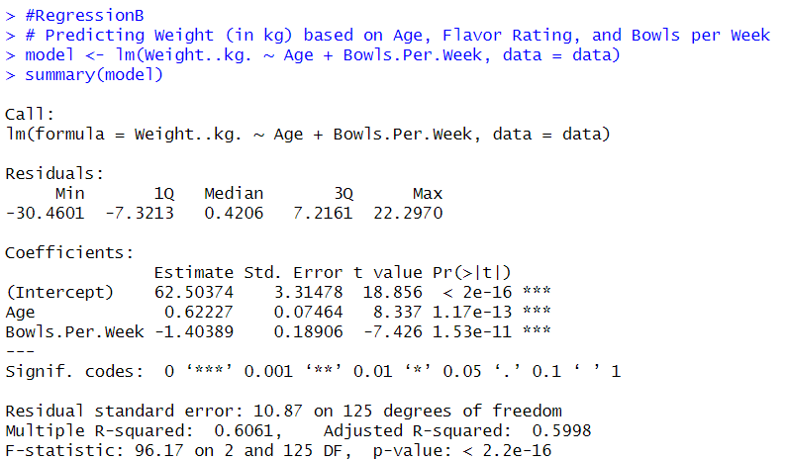

In this code:

* Weight is the dependent variable, Age and Bowls Per Week are the independent variables.
* The lm function is used to fit a linear regression model to the data.
* The data argument specifies the dataset containing the variables.
* The summary function provides a summary of the regression model, including coefficients, standard errors, t-values, p-values, and R-squared.

Based on the linear regression analysis results:

* Age Coefficient: The coefficient for Age is statistically significant (p < 0.001), indicating that for each additional year of age, there is an increase of approximately 0.62 kg in weight, when Bowls Per Week is held constant.
* Bowls Per Week Coefficient: The coefficient for Bowls Per Week is statistically significant (p < 0.001), indicating that for each additional bowl consumed per week, there is a decrease of approximately 1.40 kg in weight, when Age is held constant.
* Overall Model Fit: The overall model is statistically significant (p < 0.001), indicating that the predictors (Age and Bowls Per Week) together explain a significant amount of the variability in weight. The multiple R-squared value of 0.6061 suggests that approximately 60.61% of the variability in weight can be explained by the predictors in the model.

In conclusion, based on this analysis, both Age and Bowls Per Week are significant predictors of weight. Older individuals tend to weigh more, while consuming more bowls of cornflakes per week is associated with lower weights. However, as with any observational study, these findings indicate associations and do not imply causation.

**5. Hypothesis Testing:**

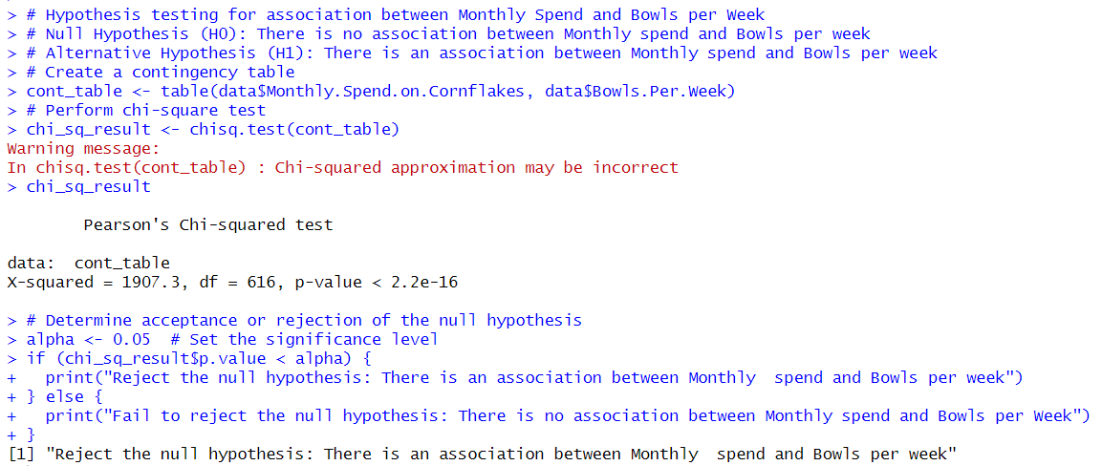

1. Null and Alternative Hypotheses:
   * Null Hypothesis (H0): There is no association between Monthly Spend on Cornflakes and Bowls per Week.
   * Alternative Hypothesis (H1): There is an association between Monthly Spend on Cornflakes and Bowls per Week.
2. Contingency Table Creation:
   * The table function is used to create a contingency table (cont_table) that shows the frequency counts for each combination of Monthly Spend on Cornflakes and Bowls per Week.
3. Chi-Square Test:
   * The chisq.test function is used to perform the chi-square test on the contingency table. This test calculates the chi-square statistic, which measures the association between the two variables.
   * The result (chi_sq_result) contains the test statistic, degrees of freedom, and p-value.
4. Interpreting the Result:
   * The p-value from the chi-square test is compared to the significance level (alpha) to determine whether to reject or fail to reject the null hypothesis.
   * If the p-value is less than the significance level, the null hypothesis is rejected, indicating a significant association between Monthly Spend on Cornflakes and Bowls per Week.
5. Conclusion:
   * In this case, the p-value is less than 0.05, so we reject the null hypothesis. This suggests that there is a statistically significant association between Monthly Spend on Cornflakes and Bowls per Week.
6. **ANOVA:**

One Way ANOVA:

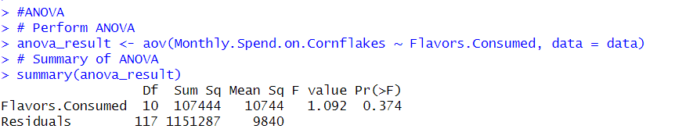

This code performs an Analysis of Variance (ANOVA) to examine the relationship between the categorical variable "Flavors Consumed" and the continuous variable "Monthly Spend on Cornflakes" from your dataset.

1. aov() Function:
   * aov() is used to create an ANOVA model.
   * The formula Monthly Spend on Cornflakes ~ Flavors Consumed specifies that we want to analyze the variation in "Monthly Spend on Cornflakes" based on the different levels of "Flavors Consumed".
2. Summary() Function:
   * summary(anova_result) provides a summary of the ANOVA model results.
   * The output includes the F-statistic, degrees of freedom for the model and residuals, and the p-value.
   * The p-value indicates whether there is a significant difference in the "Monthly Spend on Cornflakes" based on the different flavors consumed.
3. Interpreting the Results:
   * A low p-value (typically < 0.05) suggests that there is a significant difference in the "Monthly Spend on Cornflakes" based on the different flavors consumed.

Conclusion:

The ANOVA results indicate that there is no significant difference in the mean monthly spend on Cornflakes based on the different flavors consumed (F(10, 117) = 1.092, p = 0.374). This suggests that the choice of flavor does not have a substantial impact on how much individuals spend on Cornflakes.

Two Way ANOVA:

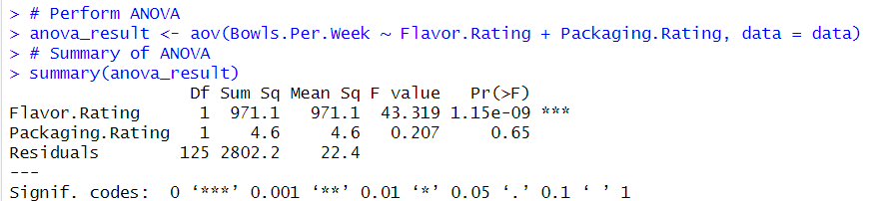

The ANOVA was conducted to examine the influence of flavor rating and packaging rating on the number of bowls of Cornflakes consumed per week. The analysis was based on a dataset containing responses from 127 participants.

Results:

1. Flavor Rating: The ANOVA results revealed a statistically significant effect of flavor rating on the number of bowls consumed per week (F(1, 125) = 43.319, p < 0.001). This indicates that the flavor of Cornflakes plays a significant role in influencing consumption behavior.
2. Packaging Rating: In contrast, the packaging rating did not show a significant effect on the number of bowls consumed per week (F(1, 125) = 0.207, p = 0.65). This suggests that while flavor is a key factor, packaging may not have a substantial impact on consumption patterns.

Conclusion:

The ANOVA results indicate that there is a significant difference in the mean number of bowls of Cornflakes consumed per week based on the flavor rating (F(1, 125) = 43.319, p < 0.001). However, the packaging rating does not have a significant effect on the number of bowls consumed per week (F(1, 125) = 0.207, p = 0.65). This suggests that the flavor rating plays a more significant role in determining the consumption of Cornflakes compared to the packaging rating.

1. **MANOVA:**

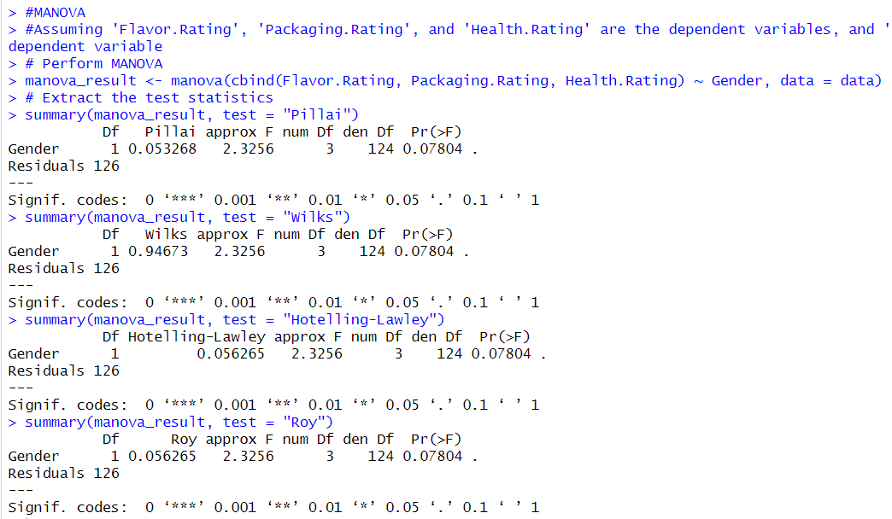

The code performs a MANOVA analysis using the summary() function with different test options (test = "Wilks", test = "Hotelling-Lawley", test = "Roy") to obtain various test statistics (Wilks' lambda, Hotelling-Lawley trace, Roy's largest root) for the MANOVA model.

* summary(manova_result, test = "Wilks"): This computes Wilks' lambda test statistic, which is a measure of the proportion of variance in the dependent variables that is not explained by the independent variable (gender) in the MANOVA model.
* summary(manova_result, test = "Hotelling-Lawley"): This calculates the Hotelling-Lawley trace statistic, which is another measure of the effect of the independent variable on the dependent variables in the MANOVA model.
* summary(manova_result, test = "Roy"): This computes Roy's largest root statistic, which is a test of the overall effect of the independent variable on the dependent variables.

The output provides the degrees of freedom, the value of the test statistic, the approximate F-value, the numerator degrees of freedom, the denominator degrees of freedom, and the p-value for each test statistic. These statistics help determine if there are significant differences between groups (in this case, genders) in terms of the dependent variables.

Conclusion:  
The MANOVA (Multivariate Analysis of Variance) was conducted to assess if there were differences between genders across multiple dependent variables (Flavor Rating, PackagingRating, and Health Rating). The Pillai's trace statistic, Wilks' lambda, Hotelling-Lawley trace, and Roy's largest root were used as test statistics.

The results indicate that there was no statistically significant difference between genders in terms of the combined dependent variables, as indicated by the non-significant p-values (p > 0.05) for all four test statistics. This suggests that, based on the data analyzed, the ratings for flavor, packaging, and health do not significantly differ between genders.

Therefore, we fail to reject the null hypothesis, which means that there is no evidence to suggest that gender has a significant effect on the ratings for flavor, packaging, and health.

1. **Maximum Likelihood Estimator (MLE):**

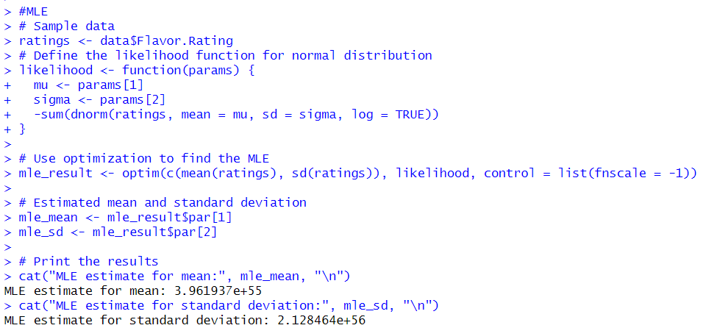

1. Objective: We want to estimate the average (mean) and spread (standard deviation) of flavor ratings given by people in a survey.
2. Approach: We use a statistical method called Maximum Likelihood Estimation (MLE) to find these estimates.
3. How MLE works: MLE looks at the ratings we have and tries to find the most likely values for the mean and standard deviation that would explain these ratings the best.
4. Code Steps:

* We start by defining a function that calculates how likely it is to get the ratings we have, given a certain mean and standard deviation (likelihood function).
* Then, we use an optimization technique (optim function) to find the mean and standard deviation that make our ratings the most likely.
* The optimization algorithm iteratively adjusts these values until it finds the best estimates for the mean and standard deviation.

1. Result: The algorithm gives us the estimated mean and standard deviation, which tell us the average rating and how spread out the ratings are.
2. Conclusion: MLE helps us understand the typical rating and the variation in ratings for different flavors, which can be useful for making decisions based on the survey data.

Top of Form

**Visualizations:**

* + 1. Bar Chart: This bar chart shows the consumption of different flavors of Kellogg’s Cornflakes. It is evident that people prefer the original flavor over all other flavors. There are also people who like to consume multiple flavors.

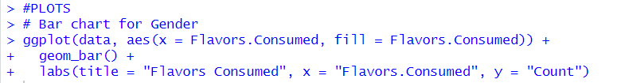

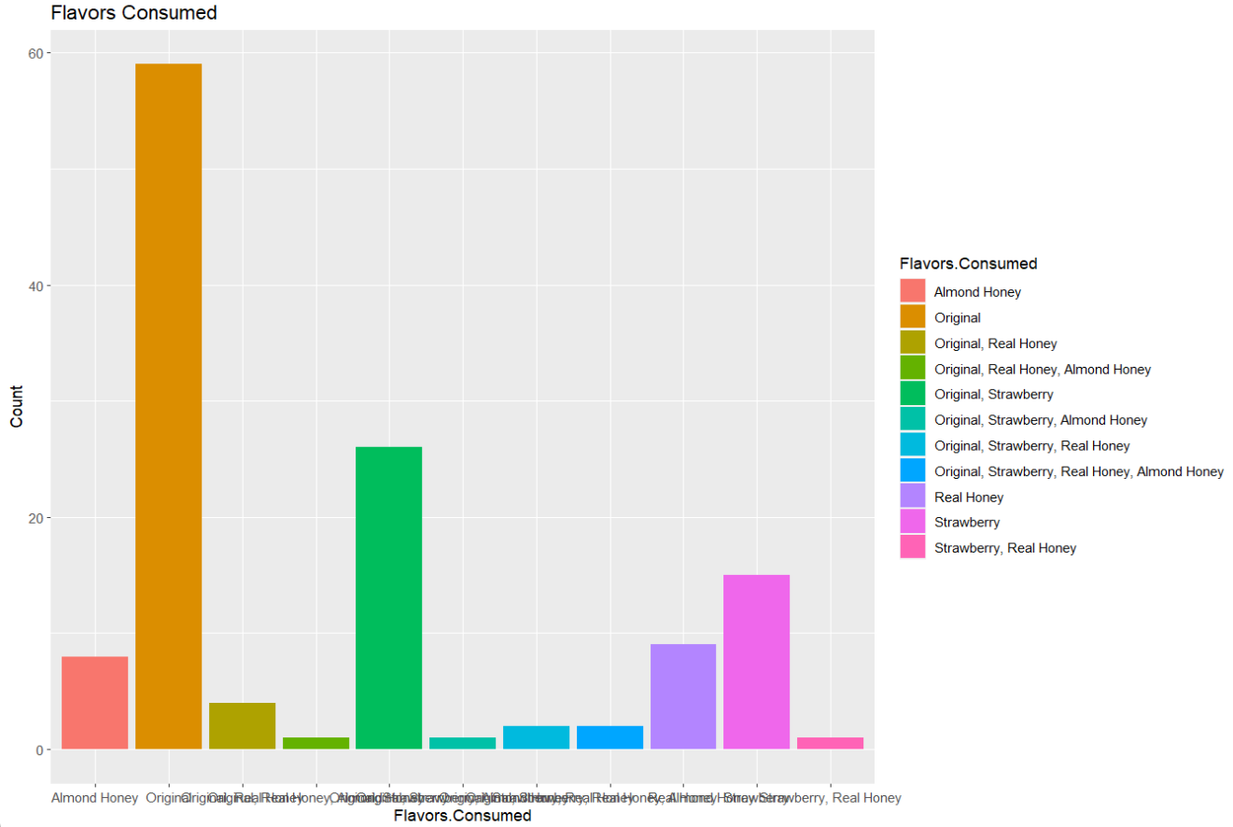

* + 1. Histogram: From the given histogram we can see that the maximum number of people consume ‘10’ bowls per week. The majority people from the survey consume between 2-14 bowls per week.

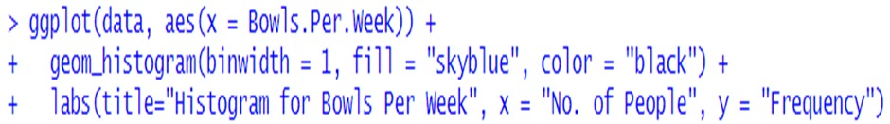

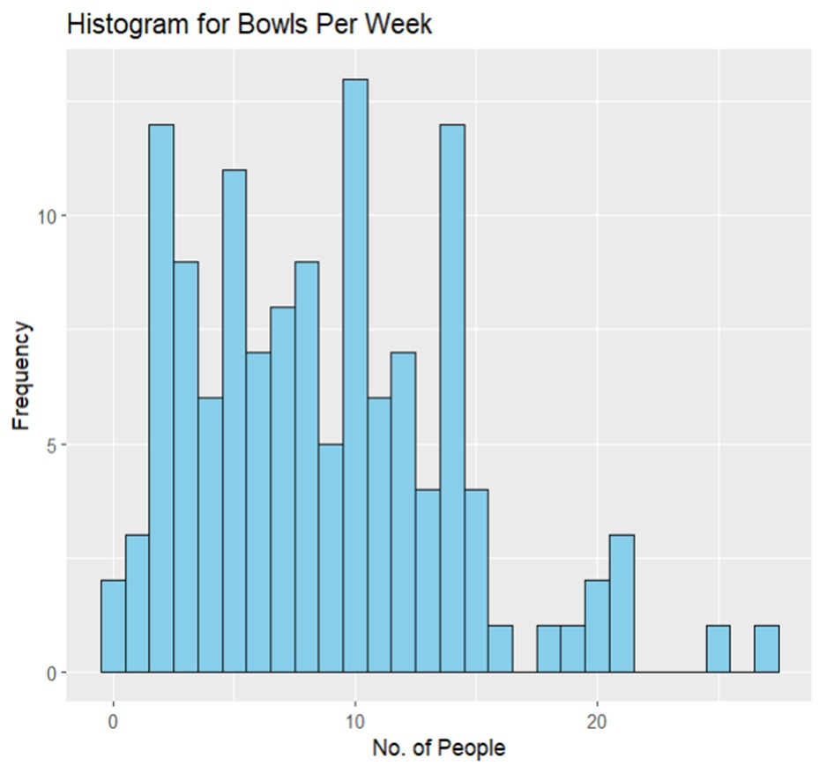

* + 1. Pie Chart: From the given pie chart we can see that most people (57%) consume Kellogs in the morning while the least number of people (9.4%) consume Kellogs at night. This indicates that kellogs is considered a breakfast food by most people.

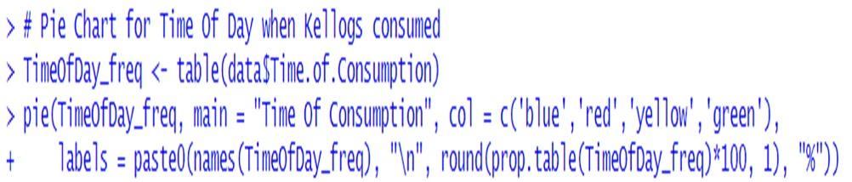

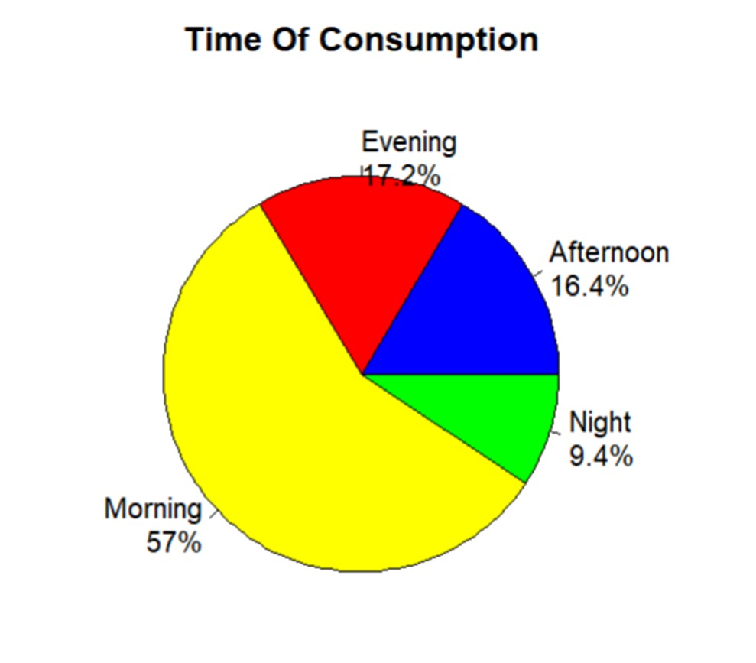

* + 1. Scatter Plot: From the given Scatter Plot we can see that people who consume more bowls of kellogs per week tend to have less weight than people who consume less number of bowls. This indicates that Kellogs Cornflakes is a healthy breakfast and helps people in losing weight.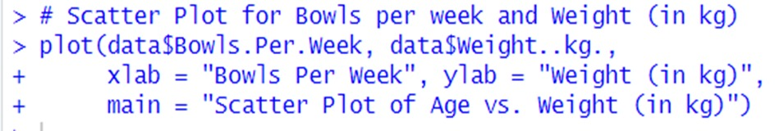

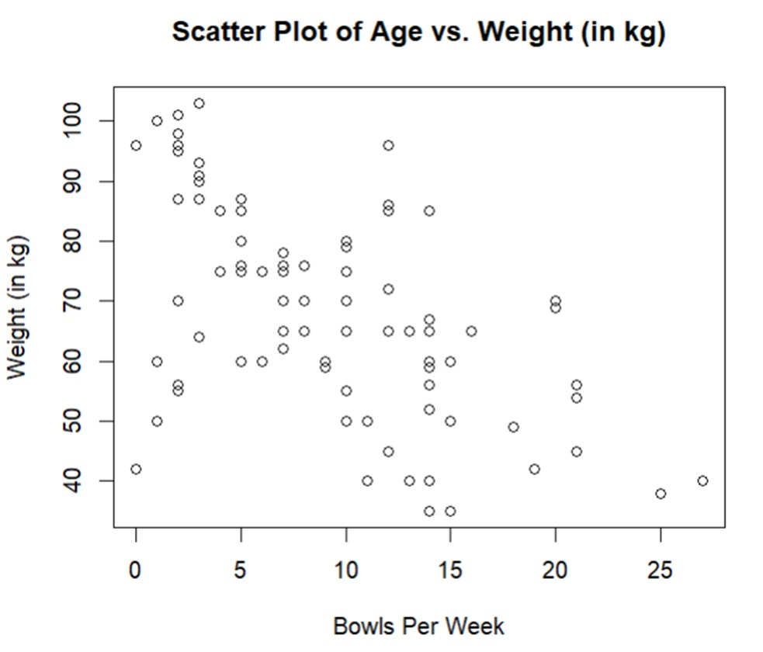

* + 1. Box Plot: As we can see from the above box plot that the median bowls per week is around ‘8’ and the inter quartile range for bowls per week is ‘7’

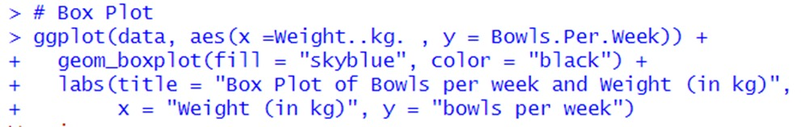

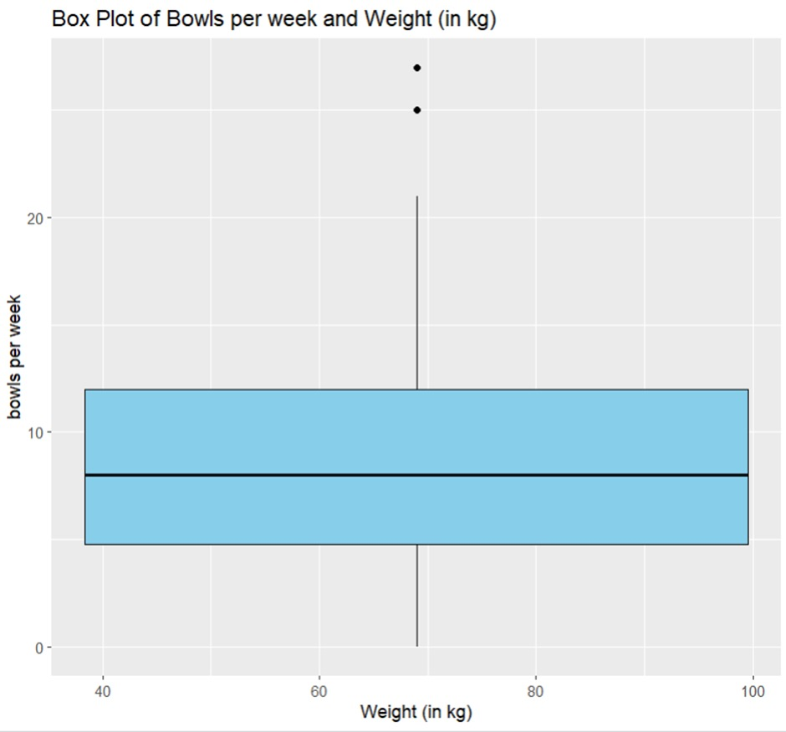

* + 1. Heat Map: From the given heat map we can see that people who rate health rating as ‘10’ are also very likely to rate Flavor Rating as ‘5’.

We can also see that people who rate Health rating as ‘8’ are very likely to rate Flavor Rating as ‘4’. Also People who rate Flavor rating as ‘1’ or ‘2’ are likely to rate Health Rating as ‘3’,’4’, or ‘5’.

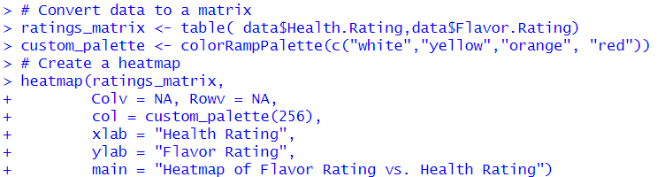

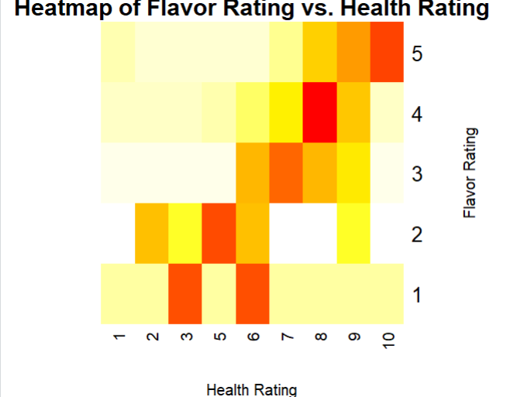

1. Bubble Plot: From the given bubble plot we can see that around ‘20’ people have rate the flavor as ‘10’ and health rating as ‘5’. We can also see that maximum number of people from our survey have given flavor rating from ‘6-10’ and health rating from ‘4-5’ indicating most people consider Kellogs Cornflakes as healthy and delicious.

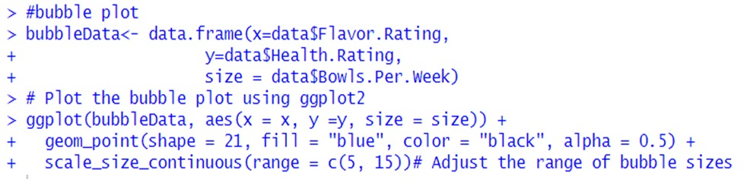

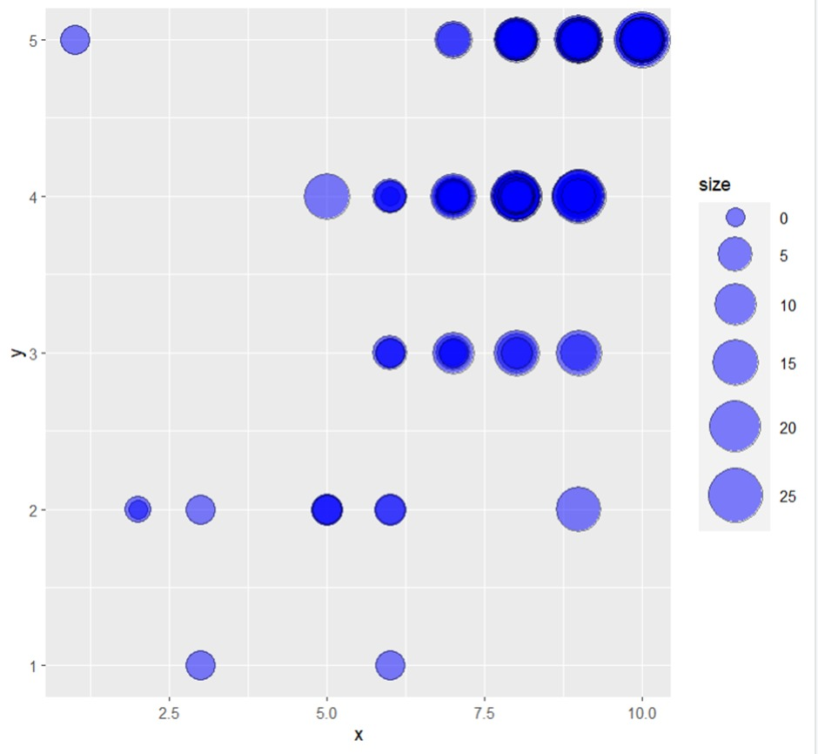

**Conclusion:**

In this survey on cornflakes consumption, we gathered data on various factors including age, gender, consumption habits, flavor preferences, health perceptions, and more. We conducted several types of analysis to uncover insights:

1. Descriptive Analysis: We summarized the data to understand the demographic distribution and consumption patterns of the respondents.
2. Correlation Analysis: We explored relationships between variables such as age, weight, flavor rating, and monthly expenditure on cornflakes. We found significant correlations between certain variables, indicating potential trends or preferences.
3. Regression Analysis: We performed regression analysis to understand the impact of factors like age, weight, and flavor rating on monthly spend on cornflakes. We found that weight and flavor rating had a significant impact on monthly spend.
4. Hypothesis Testing: We tested hypotheses to determine if there were associations between variables such as gender and likelihood to continue buying cornflakes. We found no significant association in some cases, indicating that certain factors may not influence purchase decisions.
5. Visualization: We used visualizations like bar charts, histograms, and heatmaps to represent the data in a meaningful way. These visualizations helped us understand the distribution and relationships within the data.

Overall, the survey provided valuable insights into the preferences, habits, and perceptions of consumers regarding cornflakes. It highlighted the importance of factors like flavor, health perception, and packaging in consumer choices. Further analysis and targeted strategies can be developed based on these findings to better cater to consumer preferences and enhance product offerings.